

Q5:

(a)

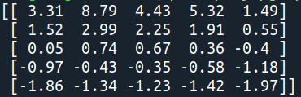

Same as Figure 3.2

(b)

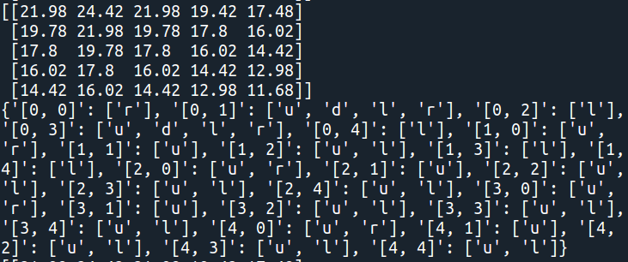

Same as Figure 3.5. The dictionary contains derived optimal policy, which key is state and value is action.

(c)

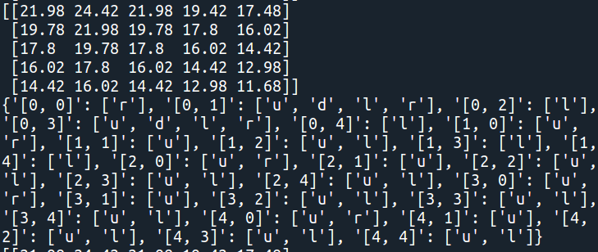

Q6:

1. I wrote the code but fail to implement it.
2. The reward will change when making those modifications. When a employee is able to help switching cars the cost on switching will decrease from num_movedCars to (num_movedCars - 1), in this case the optimal policy should be tend to switch more cars. And when the parking lot charge for extra fees there will be an extra cost which result in lower reward, so the optimal policy should be tend to keep less cars in both locations.

